IoT-Based Smart Greenhouse Monitoring System with a Simulation Dashboard
Project Proposal Report
Fathima Hasna Mohammed Nishpar
Student ID : K2635977
MSc in IT & Strategic Innovation
Supervisor: Dr . Dilina Herath
Department of Information Technology
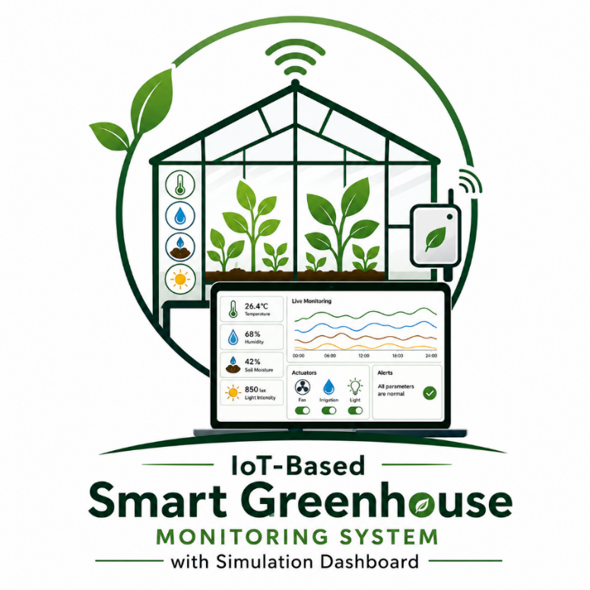
2026

Declaration
I declare that this proposal is entirely my own work. It does not incorporate, without acknowledgement, any material previously submitted for a degree or diploma at any other institution. To the best of my knowledge, it contains no material previously published or written by another person, except where proper acknowledgement has been made.

Name: Fathima Hasna Mohammed Nishpar
Student ID : 2635977
Signature: hasna

Abstract
Greenhouse farming has the potential to significantly improve agricultural productivity, but traditional approaches remain heavily reliant on manual labour and supervision. Factors such as temperature, humidity, soil moisture, and light intensity all need to be kept within specific ranges for crops to grow well, and monitoring these by hand is both time-consuming and error-prone. Existing IoT-based smart greenhouse systems go some way to addressing this, but they are almost always tied to physical hardware, which raises the cost and risk of experimentation considerably.
This project sets out to develop an IoT-Based Smart Greenhouse Monitoring System with a Simulation Dashboard that tackles this problem differently. Rather than requiring real sensors and actuators, the system generates environmental data through a software-based simulation engine and presents it through a web-based dashboard. Users can activate virtual controls, such as irrigation, cooling fans, and lighting, and observe how the simulated environment responds. When physical sensors are available, the same dashboard switches into live mode and displays real readings instead, giving the system a flexible dual-mode capability.
The aim is to produce a system that is genuinely useful for learning, research, and the early stages of adopting smart greenhouse technology, without the expense or risk of deploying physical hardware. The project will be developed using an Agile approach and evaluated against the objectives defined in the proposal.
Keywords: Internet of Things, Smart Greenhouse, Simulation Dashboard, Environmental Monitoring, Real-Time Visualisation, Automation, Design Science Research.

Table of Contents
Declaration 2
Abstract 3
1. Introduction 5
2. Background and Literature Survey 6
2.1 Background 6
2.2 Literature Survey 6
3. Research Gap 7
4. Research Problem 9
5. Proposed System 10
6. Aims and Objectives 11
6.1 Aim 11
6.2 Specific Objectives 11
7. Research Methodology 12
7.1 Research Approach 12
7.2 Data Collection and Evaluation Strategy 12
7.2.1 Simulation Validation 12
7.2.2 Functional Testing 13
7.2.3 Usability Evaluation 13
7.3 System Architecture 13
7.4 Simulation Approach 15
7.5 Software Development Methodology 15
8. Project Requirements 16
8.1 Functional Requirements 16
8.2 Non-Functional Requirements 16
8.3 Software and Tools 16
9. Project Timeline 17
10. Expected Outcomes 18
11. Budget 18
12. References 19
18

1. Introduction
Agriculture continues to be one of the most important sectors in ensuring food security, and greenhouses play a key role in making crop production more reliable and efficient. However, in many settings, greenhouse management still depends on manual observation and adjustment of environmental conditions, which is not only labour-intensive but also inconsistent. Temperature, humidity, soil moisture, and light intensity all need to be carefully maintained, and even brief deviations from optimal ranges can affect plant health and crop yield [1].
Over the past decade, Internet of Things (IoT) technologies have opened up new possibilities for automating greenhouse monitoring and control. Systems that use sensors to collect environmental data and actuators to respond to changing conditions are now well established in the research literature. However, one limitation that comes up repeatedly is that these systems are almost always hardware-dependent. To build, test, and experiment with them, you need the physical components, which means cost, setup time, and the risk of making the wrong control decision on a live crop. For students and researchers who want to study or demonstrate smart greenhouse concepts, this is a significant barrier [2].
I became interested in this problem because I wanted to find a way to explore smart greenhouse technology without needing all the physical infrastructure. The idea behind this project is to build a system that simulates greenhouse sensor behaviour through software, so that the environmental monitoring and control logic can be developed, tested, and demonstrated entirely on a computer. At the same time, the system is designed so that real sensors can be plugged in later if needed, switching it from simulation mode to live mode.
The result is an IoT-Based Smart Greenhouse Monitoring System with a Simulation Dashboard, a web-based platform that generates simulated readings for temperature, humidity, soil moisture, and light intensity, applies rule-based control logic, and presents everything through an interactive dashboard. This proposal sets out the background, research problem, methodology, and plan for developing that system.

2. Background and Literature Survey

2.1 Background
Greenhouses create a controlled growing environment that shields crops from adverse weather, but maintaining that environment takes effort. The key parameters, temperature, humidity, soil moisture, and light, all interact with one another and with plant physiology in ways that are not always predictable. Too much or too little of any one factor can reduce yields or damage crops entirely [3]. Traditionally, farmers have managed these parameters through manual inspection and adjustment, which works reasonably well on a small scale but becomes increasingly difficult as the size of the operation grows.
IoT technology offers a way to automate much of this process. Sensors deployed within the greenhouse continuously feed data back to a central system, which can then trigger actuators, such as irrigation pumps, ventilation fans, or heating systems, in response to changing conditions [4]. Research in this area has grown substantially in recent years, and there is now good evidence that IoT-based systems can reduce water usage, cut energy costs, and improve crop consistency [5].
That said, most of the systems described in the literature are built around real hardware. This makes sense for production deployments, but it creates difficulties for anyone who wants to study or experiment with the concepts without making a significant investment. A simulation-based approach offers a practical alternative: by modelling sensor behaviour and environmental dynamics in software, it becomes possible to develop and test the system logic without any physical components. This kind of approach is already common in other engineering fields, such as control systems and robotics, but it has not been widely applied to smart greenhouse monitoring [6].

2.2 Literature Survey
A number of recent studies are relevant to the proposed project. Research into IoT-based greenhouse monitoring has consistently shown the value of continuous, automated data collection. For example, systems that monitor soil moisture in real time and trigger irrigation automatically have been shown to reduce water consumption significantly while maintaining or improving yields [7]. These results are promising, but the systems in question all rely on physical sensor networks.
Work on simulation in agricultural and environmental systems is less common but has demonstrated the usefulness of modelling approaches for education and decision support [8]. Virtual environments allow users to explore how a system behaves under different conditions without any real-world risk, which is particularly valuable during the design and training phases. However, there is very little research that combines simulation with an interactive monitoring dashboard specifically for greenhouse environments.
There is also growing interest in web-based dashboards for presenting real-time sensor data in a way that non-technical users can understand and act on [9]. Such dashboards typically pull data directly from physical sensors, but there is no fundamental reason why the same interface could not be fed by a simulation engine instead. Combining these ideas, a simulation engine, rule-based control logic, and an interactive web dashboard, into a single integrated system is the gap that this project aims to fill [10].

3. Research Gap
After reviewing the existing literature and a number of representative systems, a consistent pattern emerges: current smart greenhouse solutions are designed around physical hardware and offer no way to simulate or experiment with environmental conditions independently. This is a meaningful limitation, particularly for educational use and early-stage research.
Research A, an IoT-based precision irrigation system, is a good example of the state of the art. It monitors soil moisture, light, and temperature effectively and automates irrigation, but it is entirely dependent on real sensors. There is no provision for simulating what would happen if conditions changed, or for testing different control strategies in a safe environment.
Research B, a smart tomato cultivation system, includes an interactive dashboard and automated irrigation, but again, all data comes from physical hardware. The monitoring capabilities are limited, and users have no way to explore scenarios without deploying equipment in an actual greenhouse.
Research C, an indoor seed germination system, covers several environmental parameters but lacks automated control and any form of simulation. It is useful for what it does but cannot address the broader challenge of studying greenhouse behaviour.
Research D, a LoRaWAN-based system, offers solid monitoring and a real-time alert dashboard, but like the others, it provides no simulation capability and does not support the kind of exploratory control that this project aims to enable.
The table below summarises how these existing systems compare with the proposed system. The key gap is clear: none of them includes a simulation mode, and none combines all four of the capabilities that the proposed system is designed to offer.

System / Research | Environmental Monitoring | Automated Control | Simulation Mode | Interactive Dashboard
Research A – IoT Precision Irrigation | Yes | Yes | No | No
Research B – Smart Tomato Cultivation | Partial | Yes | No | Yes
Research C – Indoor Germination System | Yes | No | No | No
Research D – LoRaWAN IoT System | Yes | No | No | Yes
Proposed System | Yes | Yes | Yes | Yes
Table 1: Comparison between existing systems and the proposed system

4. Research Problem
The core problem this project is trying to solve is straightforward to state but not so easy to address. Existing smart greenhouse systems work well when you have the hardware, but they are difficult to access, test, or learn from without it. Physical sensors and actuators are expensive, require setup and calibration, and mean that any testing of control strategies has to happen in a real greenhouse with real crops at risk.
For someone like me, studying this area as part of an MSc project and working within the constraints of academic research rather than a commercial deployment, this creates a genuine obstacle. I want to be able to build a fully functional smart greenhouse monitoring system, test its behaviour under a range of conditions, and demonstrate that the control logic works correctly, all without needing a physical greenhouse.
This leads to the central research question: How can a smart greenhouse monitoring system be designed so that environmental conditions can be monitored, visualised, and controlled in real time through a simulation-based approach, enabling safe testing and evaluation without dependence on physical sensor hardware?
Answering this question requires more than just displaying numbers on a screen. The system needs to generate realistic environmental data, apply meaningful control logic, and reflect the consequences of control actions in a way that mirrors how a real greenhouse would behave. It also needs to be designed so that real sensors can be connected in future, making the simulation a stepping stone rather than a permanent substitute.

5. Proposed System
The proposed system is a web-based IoT Smart Greenhouse Monitoring System with a Simulation Dashboard. Its purpose is to bring together three things that currently exist separately in the literature: environmental monitoring, automated control logic, and a simulation capability, into one accessible platform.
The heart of the system is a simulation engine. This is a software component that generates values for temperature, humidity, soil moisture, and light intensity and updates them over time according to defined rules. The behaviour is designed to be realistic: temperature rises gradually during the day and falls at night, soil moisture decreases as time passes and increases when virtual irrigation is activated, and so on. When a parameter moves outside its optimal range, the rule-based control logic triggers the relevant virtual actuator automatically. If the user prefers, they can switch to manual mode and toggle the actuators themselves to see the effect.
The dashboard is where the user interacts with all of this. It displays live charts and gauges showing the current state of each environmental parameter, provides controls for switching between automatic and manual modes, shows trend data over time, and raises alerts when values reach critical levels. Everything updates in real time as the simulation runs.
The system is designed to run in two modes. In simulation mode, everything is driven by the software engine, and no hardware is needed. In live mode, the same dashboard can accept readings from physical sensors instead, displaying real data rather than simulated values. This dual-mode design is one of the more distinctive aspects of the project, as it means the system can serve both as a learning and research tool and as a practical monitoring application if the hardware is available.
Taken together, the proposed system addresses the research problem identified above by providing a complete, testable, and hardware-independent platform for studying smart greenhouse behaviour.

6. Aims and Objectives

6.1 Aim
The aim of this project is to design, develop, and evaluate an IoT-Based Smart Greenhouse Monitoring System with a Simulation Dashboard that enables real-time monitoring, visualisation, and simulation of greenhouse environmental conditions, allowing users to safely test and evaluate automated control strategies without requiring physical sensor hardware.

6.2 Specific Objectives
- To review current IoT applications in greenhouse monitoring and smart agriculture, and to identify key limitations in existing hardware-dependent approaches.
- To design a software-based simulation engine that generates realistic environmental data for temperature, humidity, soil moisture, and light intensity.
- To develop a web-based simulation dashboard that visualises environmental data in real time using charts, gauges, and status indicators.
- To implement rule-based automated control simulations, including irrigation, cooling, and lighting, that respond to simulated sensor readings.
- To provide a dual-mode architecture that supports both simulation-generated data and live readings from physical sensors.
- To evaluate the system's performance, simulation realism, and usability through structured testing against the defined functional and non-functional requirements.

7. Research Methodology
This section explains how the research questions will be answered, what methods will be used to collect and evaluate information, and how the development work will be structured.

7.1 Research Approach
The methodology adopted for this project is Design Science Research (DSR), a well-established approach in information systems and computing research that is particularly suited to projects where the main output is an artefact, in this case the simulation dashboard system itself [A].
DSR involves three core activities: identifying a real problem, designing and building an artefact that addresses it, and evaluating whether the artefact actually solves the problem. These activities are not strictly sequential; in practice they overlap and iterate, which fits well with the Agile development approach used for the software work. The research process for this project follows that structure:
- Problem identification: The limitations of hardware-dependent smart greenhouse systems are identified through a literature review and a comparison of existing solutions. This is covered in Sections 2 and 3.
- Artefact design and development: The simulation dashboard system is designed and built in response to the identified problem. The design decisions, including the choice of a simulation engine, rule-based control logic, and dual-mode architecture, are all motivated by the need to address specific gaps in existing approaches.
- Evaluation: The completed system is evaluated against a set of defined criteria to determine whether it successfully answers the research question. The evaluation strategy is described below.
This approach was chosen over alternatives such as a pure experimental or survey-based methodology because the research question is fundamentally about what can be built rather than about measuring a pre-existing phenomenon. DSR is the appropriate framework when the goal is to produce a novel and useful artefact and to demonstrate that it works.

7.2 Data Collection and Evaluation Strategy
Because the project is simulator-based, there is no real-world sensor data to collect during development. Instead, data collection for evaluation purposes takes three forms.

7.2.1 Simulation Validation
The first step is to verify that the simulation engine generates realistic environmental data. This will be done by comparing the simulated parameter values and their responses to control actions against the expected ranges and behaviours described in the literature. For example, temperature values should fall within greenhouse norms (typically 18–30°C), and activating the virtual cooling fan should produce a measurable and appropriately paced decrease in the simulated temperature. If the simulation behaves realistically in these respects, it can be considered a valid model for the purposes of the project.

7.2.2 Functional Testing
The second form of evaluation is structured functional testing. Each functional requirement defined in Section 8 will be tested systematically to confirm that the system behaves as specified. This includes unit testing of individual components, such as the simulation engine and the control logic, and integration testing of the full system to ensure that all parts work together correctly. Test cases will be defined in advance and documented as part of the project deliverables.

7.2.3 Usability Evaluation
The third form of evaluation focuses on the dashboard interface. A small-scale usability test will be conducted in which a group of participants (fellow students or colleagues with relevant backgrounds) are asked to complete a set of defined tasks using the dashboard, for example locating a specific sensor reading, manually activating a virtual actuator, and interpreting a trend chart. Feedback will be collected using a structured questionnaire based on recognised usability metrics such as the System Usability Scale (SUS). The results will be used to identify any significant usability issues and to assess whether the interface meets the requirement for being intuitive and easy to use.
Together, these three forms of evaluation provide a rounded assessment of the system: the simulation engine is validated against domain knowledge from the literature, the software is tested against its functional requirements, and the user interface is assessed through direct user feedback.

7.3 System Architecture
The proposed system follows a layered architecture that cleanly separates data generation, processing, and presentation. The first layer is the simulation and data layer, which is responsible for generating environmental values or, where physical sensors are available, receiving live readings. The second layer is the processing and control layer, which applies rule-based logic to evaluate incoming data and decide whether virtual actuators should respond. The third layer is the web-based presentation layer, the simulation dashboard through which users monitor conditions, view trends, and interact with the system.
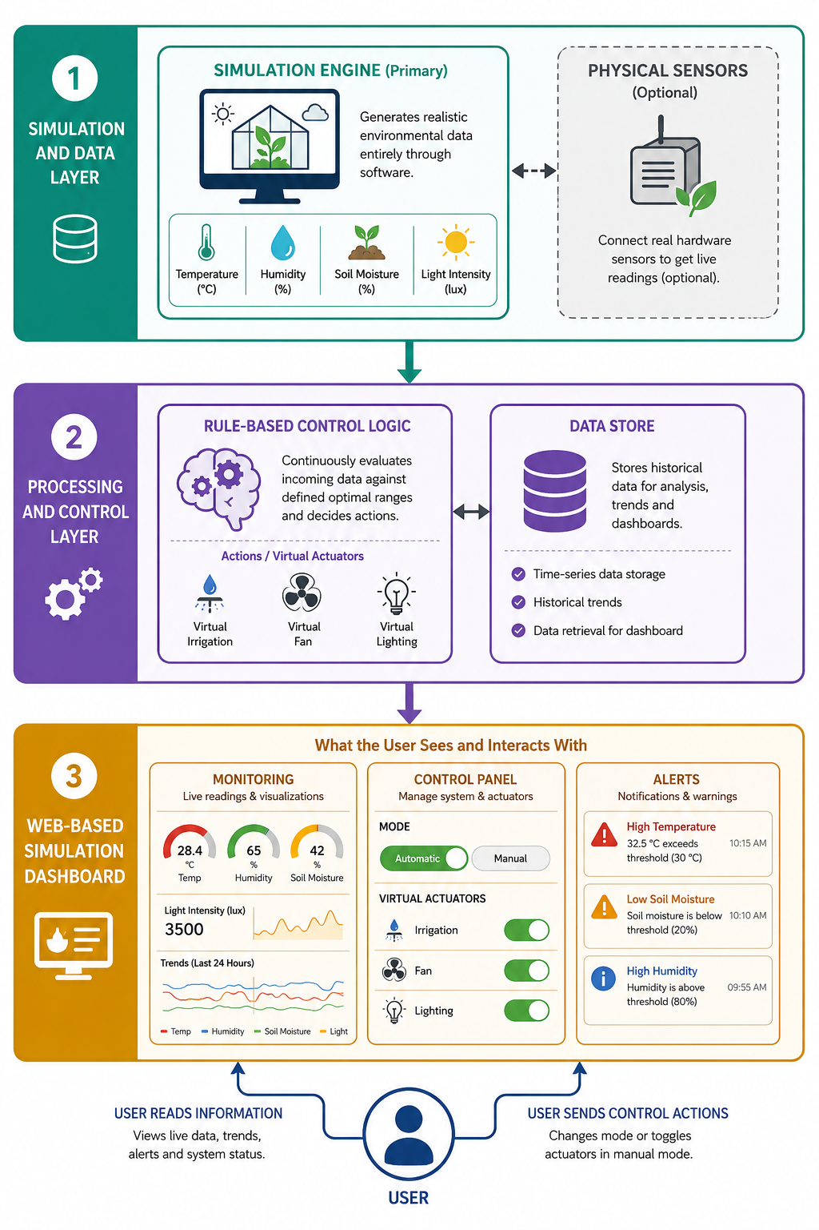
Data produced by the simulation engine is stored in a lightweight database so that trends can be visualised over time. The processing layer runs continuously, comparing current values against defined optimal ranges and triggering actuators when necessary. All changes are reflected on the dashboard in real time. The overall architecture is illustrated in Figure 1.

Figure 1: High-level system architecture of the proposed simulation-based smart greenhouse

7.4 Simulation Approach
The simulation engine models each environmental parameter as a time-varying value governed by defined rules. Baseline behaviour reflects natural patterns, such as temperature rising during simulated daytime and falling overnight, while control actions produce deliberate changes. Activating virtual irrigation, for instance, causes soil moisture to rise at a defined rate, while deactivating it allows moisture to drain gradually. The engine runs on a configurable time step so that scenarios can be explored at different speeds.
Rule-based control logic is applied on top of the simulation. Each parameter has an optimal range, and when a value falls outside that range the relevant virtual actuator is triggered. The same logic governs both the automated and manual control modes available through the dashboard. This rule-based approach was chosen over a more complex algorithmic model because it is transparent, testable, and sufficient for the goals of the project. Adding more sophisticated control logic, such as predictive models, could be explored as a future extension.

7.5 Software Development Methodology
The software will be developed using an Agile approach, specifically the Scrum framework. Agile was chosen because the requirements of the project are likely to evolve as development progresses, and because it allows the work to be broken into manageable increments, each of which can be reviewed and refined before moving on. Sprints will typically last two to three weeks, and each sprint will deliver a specific piece of working functionality.
The main development phases are as follows:
- Requirements gathering: Functional and non-functional requirements are identified and recorded in a product backlog.
- Design and prototyping: The system architecture, simulation logic, and dashboard wireframes are designed before development begins.
- Development: The simulation engine, control logic, and dashboard are built sprint by sprint.
- Testing and quality assurance: Unit, integration, and usability testing take place alongside development throughout the project.
- Deployment: The completed system is deployed as a web application for evaluation.
- Review and iteration: Sprint retrospectives are used to identify improvements and inform subsequent sprints.

8. Project Requirements

8.1 Functional Requirements
- The system shall generate simulated environmental data for temperature, humidity, soil moisture, and light intensity.
- The system shall display environmental data on a real-time dashboard using charts, gauges, and indicators.
- The system shall apply rule-based logic to automatically activate virtual actuators when parameters move outside their optimal ranges.
- The system shall allow users to manually toggle virtual actuators, including irrigation, cooling, and lighting, and observe the resulting changes in simulated values.
- The system shall raise alerts and notifications when environmental parameters reach critical thresholds.
- The system shall support a dual-mode design, operating on simulated data by default and switching to live sensor readings when physical sensors are connected.

8.2 Non-Functional Requirements
- Performance: The dashboard must reflect updates to environmental data and control actions in real time with no perceptible delay.
- Usability: The interface must be straightforward enough for users with no specialist technical background to navigate and use effectively.
- Reliability: The simulation engine must produce consistent results across repeated runs under the same conditions.
- Scalability: The system should be structured so that additional parameters or features can be incorporated in future without major rework.
- Maintainability: The code should be clearly structured and documented to support future maintenance and the potential integration of physical sensors.

8.3 Software and Tools
Since the project is simulator-based, no specialised hardware is required. Development will be carried out on a standard laptop. The planned tools and technologies include Python or JavaScript for the simulation engine and control logic, a suitable web framework for the application layer, HTML, CSS, and JavaScript for the dashboard interface, a charting library for data visualisation, and a lightweight database for storing historical simulation data. The specific choices will be confirmed during the design phase, once the architecture has been fully specified.

9. Project Timeline
The project runs from February to December 2026, aligned with the university’s Spring and Autumn semesters and the GT7000 Dissertation module schedule. The key submission deadlines are the Proposal Submission on 30 May 2026 (10%), the Dissertation Submission on 19 December 2026 (80%), and the VIVA on 22 December 2026 (10%). The main activities and their planned sequence are shown in the Gantt chart in Figure 3.
- Spring semester (Feb–May): Supervisor meetings, feasibility study, requirement analysis, literature review, system architecture design, and proposal submission.
- Summer break (Jun–Aug): Simulation engine design and prototyping, rule-based control logic design, and early development of the simulation engine.
- Autumn semester (Sep–Dec): Dashboard frontend development, backend and data store integration, dual-mode feature implementation, unit and integration testing, usability testing, system evaluation, dissertation writing, and final report preparation.
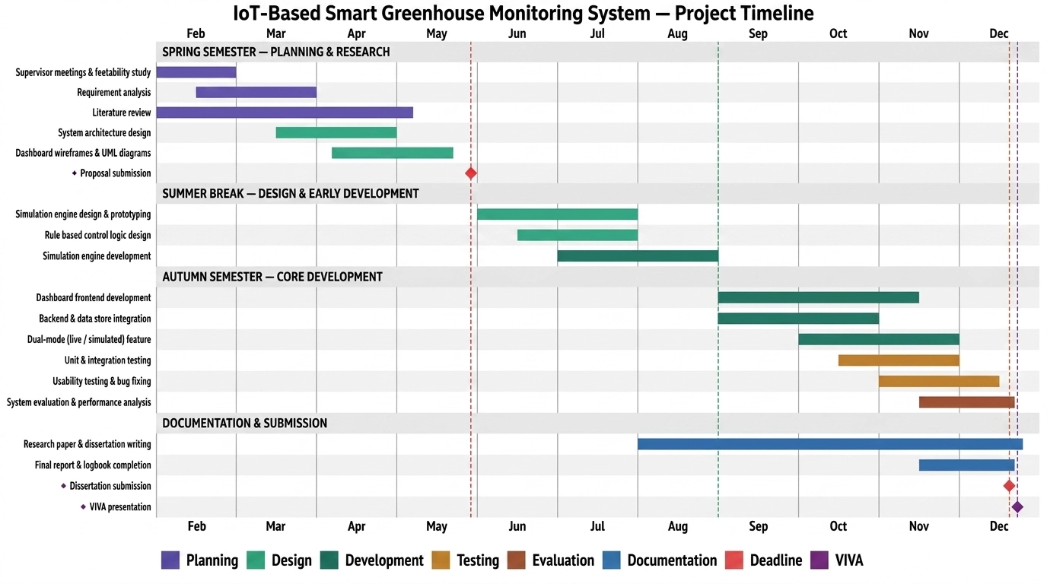

Figure 3: Project Gantt chart aligned with university submission schedule (GT7000 Dissertation, Feb–Dec 2026)

10. Expected Outcomes
By the end of the project, I expect to have produced a fully working web-based simulation dashboard that demonstrates the core concepts of IoT-based greenhouse monitoring without requiring any physical hardware. The simulation engine should generate realistic environmental data, the rule-based control logic should respond correctly to out-of-range values, and the dashboard should present all of this in a clear and usable way.
Beyond the software itself, the project should produce evidence, through the functional testing and usability evaluation, that the system meets its stated requirements and that the simulation-based approach is a viable way to study and demonstrate smart greenhouse behaviour. The dual-mode design means there is also a clear path to extending the system with real sensors in future, which gives the work practical as well as academic value.
More broadly, the project contributes to a small but growing body of work on simulation approaches in agricultural IoT, and I hope it will be useful to others who want to explore this area without the cost and complexity of a full hardware deployment.

11. Budget
One of the practical advantages of the simulator-based approach is that it keeps costs low. There is no need to purchase sensors, microcontrollers, or actuators for the core system. The main costs relate to cloud hosting for the deployed web application, internet access for research, and a contingency allowance for unexpected expenses. An estimated budget is presented in Table 2.

Category | Item / Description | Estimated Cost (LKR)
Software | Development laptop / workstation (existing) | 0.00
Software | Cloud hosting for dashboard deployment | 6,000.00 / month
Software | Domain name registration | 3,500.00
Software | Development tools (open-source) | Free
Research | Internet charges for research | 5,000.00
Research | Reference materials and documentation | 2,500.00
Contingency | Unexpected costs (testing, revisions) | 5,000.00
Table 2: Estimated project budget

All development tools are open-source, which eliminates software licensing costs. Cloud hosting is the main recurring expense and is necessary to make the dashboard accessible as a live web application during evaluation.

12. References
[1] A. Chauhan and P. Tripathy, “Internet of Things (IoT) integrated solutions for environmentally friendly intelligent farming: A systematic review,” in Proc. 3rd Int. Conf. on Advance Computing and Innovative Technologies in Engineering (ICACITE), May 2023, doi: 10.1109/ICACITE57410.2023.10182525.
[2] C. Maraveas et al., “Agricultural greenhouses: Resource management technologies and perspectives for zero greenhouse gas emissions,” Agriculture, vol. 13, no. 7, p. 1464, Jul. 2023, doi: 10.3390/agriculture13071464.
[3] N. Castilla, “Greenhouse production strategies,” in Greenhouse Technology and Management, pp. 262–265, Dec. 2012, doi: 10.1079/9781780641034.0262.
[4] D. Van Ploeg and E. Heuvelink, “Influence of sub-optimal temperature on tomato growth and yield: A review,” Journal of Horticultural Science and Biotechnology, vol. 80, no. 6, pp. 652–659, Jan. 2005, doi: 10.1080/14620316.2005.11511994.
[5] N. Bafdal and I. Ardiansah, “Application of Internet of Things in smart greenhouse microclimate management for tomato growth,” Int. Journal on Advanced Science, Engineering and Information Technology, vol. 11, no. 2, pp. 427–432, Apr. 2021, doi: 10.18517/ijaseit.11.2.13638.
[6] A. Goap, D. Sharma, A. K. Shukla, and C. Rama Krishna, “An IoT based smart irrigation management system using machine learning and open source technologies,” Computers and Electronics in Agriculture, vol. 155, pp. 41–49, Dec. 2018, doi: 10.1016/j.compag.2018.09.040.
[7] D. Singh et al., “Smart high-yield tomato cultivation: Precision irrigation system using the Internet of Things,” Frontiers in Plant Science, vol. 14, Aug. 2023, doi: 10.3389/fpls.2023.1239594.
[8] M. H. Seyar and T. Ahamed, “Development of an IoT-based precision irrigation system for tomato production from indoor seedling germination to outdoor field production,” Applied Sciences, vol. 13, no. 9, p. 5556, Apr. 2023, doi: 10.3390/app13095556.
[9] S. Gitahi, D. M. Kaburu, I. N. Oteyo, and S. Kimani, “A model implementation of IoT-based smart watering system for crops using LoRaWAN,” in Proc. 2023 IST-Africa Conference, May 2023, doi: 10.23919/IST-Africa60249.2023.10187864.
[10] W. M. Rodriguez-Ortega et al., “Use of a smart irrigation system to study the effects of irrigation management on the agronomic and physiological responses of plants,” Agricultural Water Management, vol. 183, pp. 158–168, Mar. 2017, doi: 10.1016/j.agwat.2016.07.014.
[A] A. Hevner, S. March, J. Park, and S. Ram, “Design science in information systems research,” MIS Quarterly, vol. 28, no. 1, pp. 75–105, Mar. 2004, doi: 10.2307/25148625.

